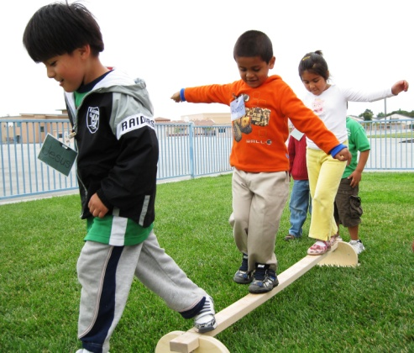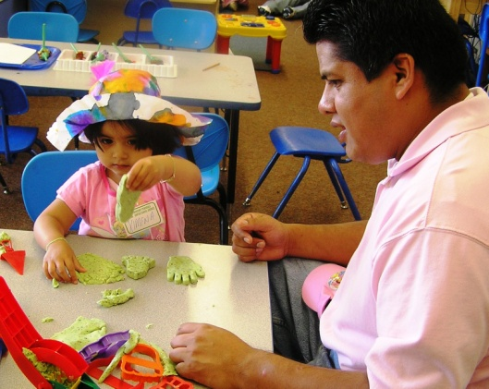

|  |
| --- |
| **Essential Characteristics:**  ***Essential Questions – Essential Thinking - Essential Being*** |

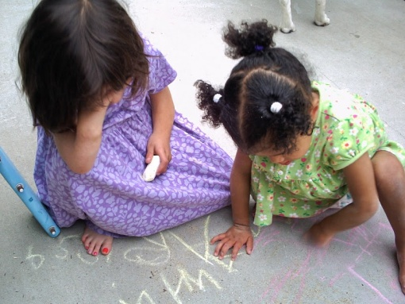



Rochelle Sherlock, M.A., Senior Consultant – rochelle_sherlock@comcast.net

Ellen Lewis, M.A., Senior Consultant – ellen@ellendlewis.com

Photos: The photos in this guide were provided by First 5 Monterey County Funded Partners, the Rerucha family, or were purchased through I-Stock photos.



|  |  |
| --- | --- |
| October 2011 | Excerpts of The Essential Characteristics  Resource Guide |

**OVERVIEW OF THE ESSENTIAL CHARACTERISTICS**

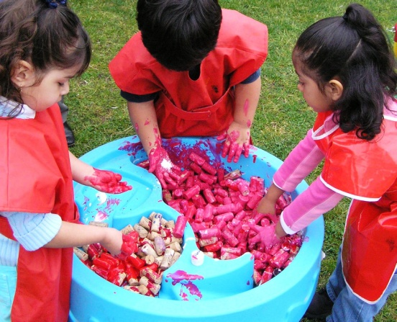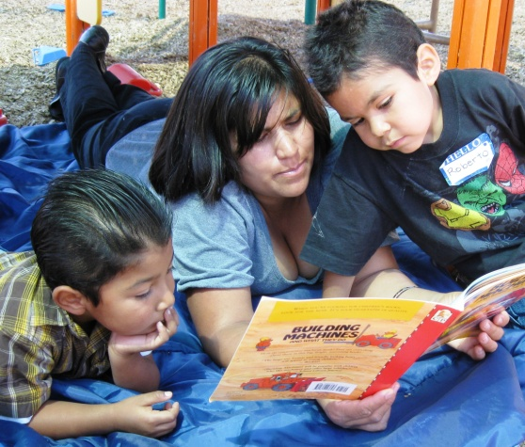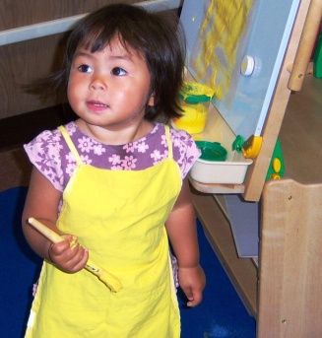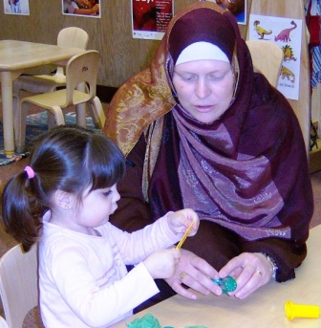

*We need to cherish and preserve the ethnic and cultural diversity that nourishes and strengthens this community – and this nation.*

*~ Cesar Chavez*

**History**

In 2005, the First 5 Monterey County (***F5MC)*** Commission selected Early Learning Opportunities (ELO) as the primary focus area for funding. A participatory planning process was conducted from 2006 to 2007. More than 1,000 voices from diverse communities in Monterey County participated with their ideas, experiences, and perspectives. The strategic process identified Community Visions and Outcomes for ELO funding. During the process the community identified a list of key characteristics they believe are essential to the success of programs, which are called ***F5MC*** *Essential Characteristics*.

**Essential Characteristics**

The five Essential Characteristics(ECs*)* are:

* *Culturally and Linguistically Appropriate,*
* *Family Centered/Centric,*
* *Community-Based,*
* *Coordinated,* and
* *Flexible Hours*

Research has shown that *how* support is provided to families is as important as *what* is provided if services are to produce positive outcomes for children and families[1]. The ECs are at the core of *how* to provide those services.

This guide reflects the work of ***F5MC*** staff, Funded Partners (FP), and two external consultants to mutually define the ECs through evidenced-based and effective best practices, and provide measurable indicators to support the integration of ECs across programs, policies, and organizations.

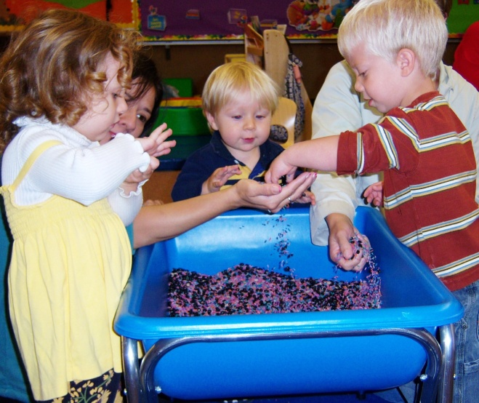



# *If a child is to keep his inborn sense of wonder, he needs the companionship of at least one adult who can share it, rediscovering with him the joy, excitement and mystery of the world in which we live. ~ Rachel Carson*



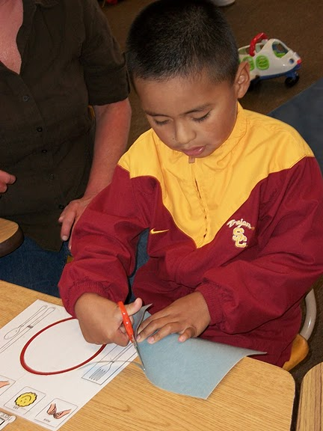

***First 5 Monterey County* Essential Characteristics**

1. Culturally and Linguistically Appropriate

*The Organization honors and respects the diversity of children and families, their socio-economic status, family structures, individual abilities, beliefs, interpersonal styles, language preferences, attitudes and behaviors. Programs and services are targeted to the primary beneficiaries in a community.*

1. Family-Centered/Centric

*The role of family as central to the health and well-being of children is recognized and supported through a respectful family-provider partnership based on equality. Families are celebrated for their strengths, expertise, cultures, and traditions; their knowledge, skills and experience are utilized collaboratively in the decision making process.*

1. Community-Based

*In the community, of the community, for the community; centered in and around a particular community, and reflective of community needs and dynamics.*

1. Coordinated

*Working together harmoniously in a collective effort to support families and children, maximize resources, reduce duplication, and produce positive outcomes for the community.*

1. Flexible Hours

*Flexible staffing and program planning to ensure services are provided at convenient times so that family members can participate year round without conflicts with school, work or other commitments; includes evenings, weekends and holidays.*

**Culturally and Linguistically Appropriate**

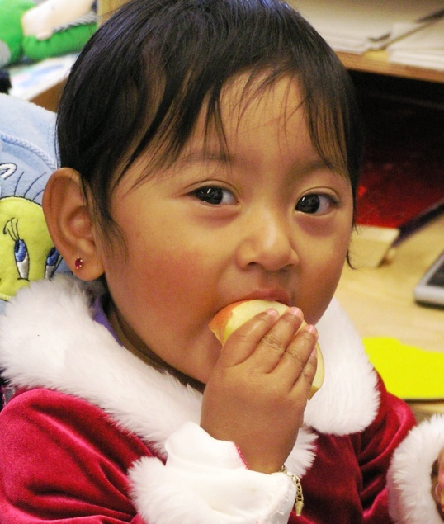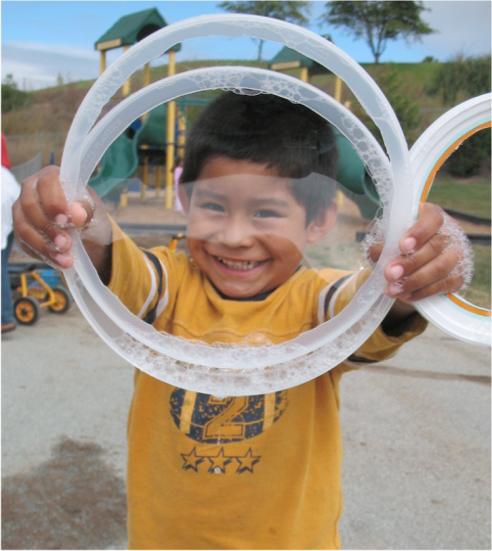

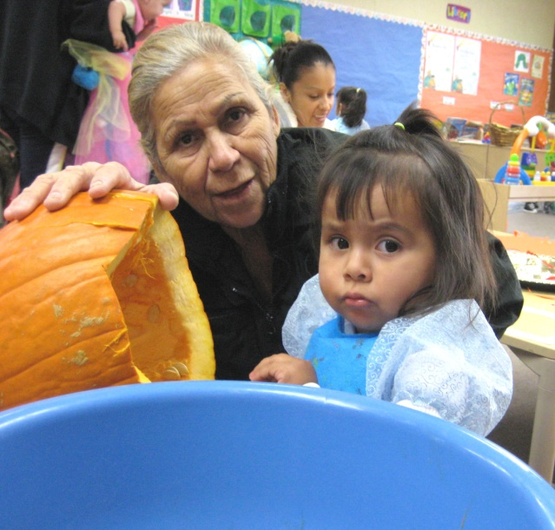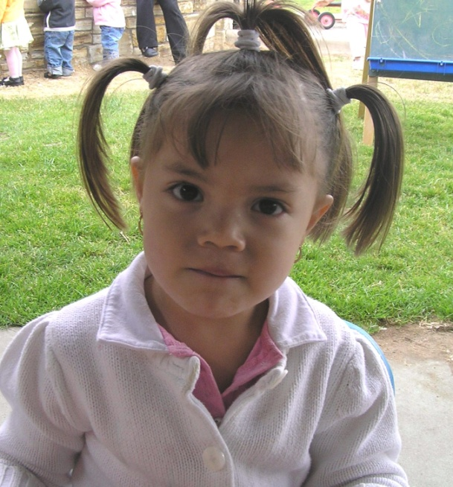

If you talk to people in a language they understand, that goes to their head. If you talk to people in their own language, that goes to their heart.

~ Nelson Mandela

Culturally and Linguistically Appropriate

The organization honors and respects the diversity of children and families, their socio-economic status, family structures, individual abilities, beliefs, interpersonal styles, language preferences, attitudes and behaviors. Programs and services are targeted to the primary beneficiaries in a community.

Monterey County is a rich tapestry of communities, cultures, families and languages. Organizations that use culturally and linguistically appropriate approaches are better able to address the multiple strengths, needs, and preferences of the families they serve. Cultural proficiency is an ongoing, life-long developmental process and requires humility. National standards were developed for Culturally and Linguistically Appropriate Services (CLAS). CLAS serve as exemplary standards of practice for organizations[2] (see Appendix A).

According to leading research*[3]*,[4],[5]*:*

*Cultural appropriateness requires that organizations:*

* Conduct program planning based on current and projected demographics;
* Build on the social strengths and natural networks of support of diverse communities;
* Recognize and address the unique social challenges of cultural groups;
* Have a congruent, defined set of principles, policies and structures, and demonstrate behaviors and attitudes that enable them to work effectively cross-culturally;
* Have the capacity to (1) respect and value diversity, (2) be flexible and self-reflective by cultivating self-awareness and

awareness of the perspective of others, (3) manage the dynamics of difference, (4) continually assess cultural dimensions (e.g., for each individual and group) and institutionalize cultural knowledge, and (5) adapt to the diversity; and

* Incorporate the above into all aspects of policymaking, administration, practice, and service delivery and systematically involve consumers, key stakeholders and communities.

*Linguistic appropriateness requires that organizations:*

* Have bilingual/bicultural or multilingual/multicultural staff, Board, and volunteers;
* Have foreign language and sign language interpretation services, TTY and other assistive and distance technology devices;
* Use print materials in easy to read, low literacy, picture and symbol formats; have materials in alternative formats (e.g., audiotape, Braille, enlarged print);
* Have bilingual signage, education and public awareness materials; materials developed and tested for specific cultural, ethnic and linguistic groups;
* Incorporate the above into all aspects of policymaking, administration, practice, and service delivery; and
* Dedicate resources to support this capacity.

**Highlights of Promising Practice: Centro Binacional**

*Centro Binacional para el* *Desarrollo Indígena Oaxaqueño (CBDIO) demonstrates culturally and linguistically appropriate organizational policies and practices (e.g., culturally/linguistically competent staff, use of promotores, etc). CBDIO was created, and is directed, by indigenous people to serve indigenous people.*

Centro Binacional para el Desarrollo Indígena Oaxaqueño (CBDIO) - Binational Center for the Development of Indigenous Communities serves indigenous migrant communities from México. Trust, safety, and a collaborative relationship is essential to the success of working with indigenous populations due to a variety of historical, legal (e.g., immigration status), cultural, and linguistic factors[6]. Recognizing those factors CBDIO established organizational practices, programs and services designed to reduce barriers and meet the needs of the communities.

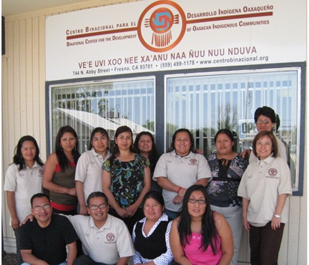

Culturally and linguistically appropriate practices include:



*En la Kech*

(Mayan expression) -

Translated means Y*ou are in me and I am in you.*



* **Staffing** –*CBDIO hires indigenous people who speak at least one indigenous language as well as Spanish*. Some staff are tri-lingual, speaking an indigenous language, Spanish and English. *The majority of the Board of Directors are from indigenous communities*, hold leadership positions within their communities, and provide feedback on the

particular challenges the communities are facing. As a result CBDIO understands the current needs and realities of the communities.

* **Promotores(as)** – *CBDIO uses indigenous community members who possess an intimate understanding of the community's natural social networks, strengths and challenges.* They serve as liaison between the indigenous communities and other non-indigenous entities to educate and support them on issues such as citizenship, health, wellness, nutrition, parenting and child development.
* **Community-Based Services** – Familiarity and safety are important considerations when serving indigenous communities. CBDIO gathers communities together in someone’s house or backyard to deliver their workshops and services.
* **Linguistically Appropriate Services** **and Materials** – Many indigenous people are mono-lingual Mixtec, Zapotec, or Triqui speakers and literacy levels are low. CBDIO provides services in the languages spoken by the indigenous people and communicates orally with minimal written materials.
* **Capacity Building of Indigenous Communities** – Differing cultural practices can present a challenge to accessing services. CBDIO has an intimate knowledge of the various cultural practices of indigenous communities as well as local practices and laws. CBDIO *builds the capacity of the indigenous communities by encouraging some adaptation of local practices while retaining core cultural beliefs and values*. For instance, it is customary in the villages of Oaxaca for people to go homes for assistance. This practice continues in the United States and community members go to the homes of the promotores(as) any time of day when they want help. CBDIO is encouraging community members to access their help by also going to the office during office hours. In order to accommodate work schedules and be more accessible CDBIO has flexible office hours.



**CBDIO Values**

* **Guelaguetza** (Mutual support)
* **Tequio** (Collective work for the community’s well-being)
* **Reciprocal existence with nature**
* **Indigenous Identity**
* **Respect**
* **Social justice**
* **Honesty**
* **Creativity**
* **Equality**
* **Responsibility**
* **Transparency**



* **Indigenous Interpreters as a Bridge Between Cultures[7]** - Language and cultural barriers have proved devastating for many indigenous migrants. As a result, CBDIO implemented the Indigenous Interpreter program where they train indigenous interpreters professionally about the social, and legal circumstances surrounding interpretation. In doing so CBDIO *addresses a key social challenge* of the communities they serve. CBDIO offers **interpretation and translation services in Mixteco, Triqui, Chatino and Zapoteco.**

The programs and practices of CBDIO are built upon existing knowledge of indigenous communities, promote social strengths and natural networks of support (e.g., working with community leaders), address social challenges such as linguistic barriers, offer services in the languages of the communities, use culturally and linguistically appropriate methodologies and materials, and are led by culturally and linguistically competent organizational staff and Board of Directors (see Appendix B for Recommendations for Working with Indigenous Communities).

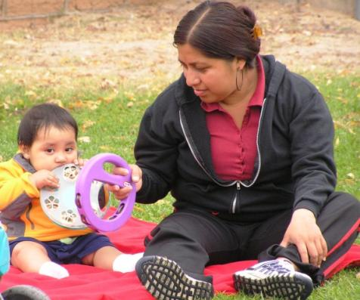

**List of Resources**

**Culturally and Linguistically Appropriate**

On-Line

**The National Center for Cultural Competence (Georgetown University)** is a tremendous resource with dozens of articles, organizational self-assessments, and promising practices. Their mission is to increase the capacity of health care and mental health care programs to design, implement, and evaluate culturally and linguistically competent service delivery systems to address growing diversity, persistent disparities, and to promote health and mental health equity. Website: <http://www11.georgetown.edu/research/gucchd/nccc/index.html>

**National Standards on Culturally and Linguistically Appropriate Services, (CLAS).** U.S. Department of Health and Human Services, The Office of Minority Health. The CLAS standards are primarily directed at health care organizations; however, individual providers are also encouraged to use the standards to make their practices more culturally and linguistically accessible. Website: <http://raceandhealth.hhs.gov/templates/browse.aspx?lvl=2&lvlID=15>

**Children in Immigrant Families in California Report, (2009).** The Center for Social and Demographic Analysis, Annie E. Casey Foundation. This brief provides information about the importance of reducing language and literacy barriers to ensure that children in immigrant families achieve success in school and work settings. Website: <http://www.aecf.org/~/media/Pubs/Topics/Special%20Interest%20Areas/Immigrants%20and%20Refugees/ChildreninImmigrantFamiliesinCalifornia/AECF_immigrant_families_brief_california/>

**Building Culturally and Linguistically Competent Services to Support Young**

**Children, Their Families, and School Readiness Toolkit.** A tool kit developed to help promote early childhood development and school readiness by the Center for Social and Demographic Analysis, Annie E. Casey Foundation. The toolkit defines cultural and linguistic competence and provides guidance, tools, and resources that will assist communities in building culturally and linguistically competent services and practices related to young children and families.

Website: <http://www.aecf.org/upload/publicationfiles/hs3622h325.pdf>

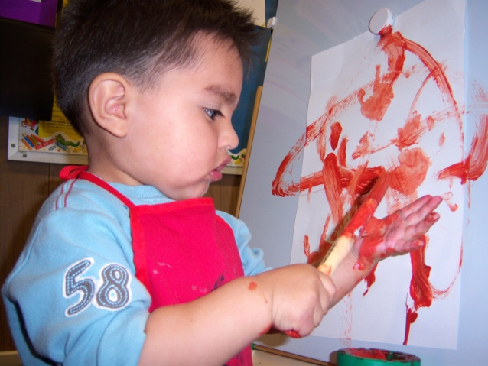

**Support a Diverse and Culturally Competent Workforce, Charting Progress for Babies in Childcare.** Center for Law and Social Policy (CLASP). CLASP is a national non-profit policy organization that develops and advocates for policies at the federal, state and local levels that improve the lives of low income people. Website: <http://www.clasp.org/admin/site/babies/make_the_case/files/cp_rationale5.pdf>

**The Changing Face of the United States: The Influence of Culture on Early Child Development**, ZERO TO THREE. The cultural beliefs, values, and behaviors within a family all have an impact on early child development. This report reviews and summarizes the latest research dealing with the impact of culture on early childhood services. Website: <http://www.zerotothree.org/site/DocServer/Culture_book.pdf?docID=6921>

**Sample Cultural and Linguistic Competency Policies and Procedures.** San Francisco Department of Public Health Policy and Procedure Document. Website: <http://www.sfdph.org/dph/comupg/aboutdph/insideDept/CLAS/CLASPolicies.asp>

**National Association for the Education of Young Children,** (2009). Quality benchmark for cultural competence project emphasizes the importance of providing high-quality, culturally competent early childhood education for children. Website: <http://www.naeyc.org/files/naeyc/file/policy/state/QBCC_Tool.pdf>

**Family Support Standards, San Francisco Family Support Network,** (2009). The Family Support Standards were created to define how the nine principles of Family Support developed by Family Support America can be applied programmatically

as a tool for planning, providing, and evaluating quality services. Website: <http://www.dcyf.org/WorkArea/showcontent.aspx?id=3706>

**Building a culturally competent organization**, (September 2008). Article on building a culturally competent organization. Working Strategies, 11(4), 1-14. Website: <http://www.familyresourcecenters.net/assets/library/101_summer08.pdf>

Books, Articles, and Materials

**Cultural proficiency: A manual for school leaders** (2nd ed.). By Lindsey, R. B., Robins, K. N., & Terrell, R. D. (2003). Thousand Oaks: Corwin Press

**Selecting culturally and linguistically appropriate materials: Suggestions for service providers.** Article by Santos, R. M. & Reese, D. (1999, June). ERIC Digest (EDO-PS-99-6).

**Working with culturally and linguistically diverse families,** (2001, August). Article by Bruns & Corso. ERIC Digest (EDO-PS-01- 4).

***Working with Indigenous Communities***

**Centro Binacional para el Desarrollo Indígena Oaxaqueño (CBDIO). CBDIO provides interpretation services in Mixteco, Triqui, Chatino and other indigenous languages; translation and assistance with letters from English into indigenous languages and Spanish; conferences, presentations and workshops on Indigenous Culture, identity and decolonization; organization and/or facilitation of Focus Groups with indigenous communities; and outreach activities targeting indigenous communities. Website:** <http://centrobinacional.org/>

**California Institute for Rural Studies:** work toward a rural California that is socially just, economically balanced, and environmentally sustainable. Focus on a comprehensive range of research topics including farm labor conditions, sustainable food systems, immigration reform, immigrant civic participation, rural health, pesticide use, and water policy. Website: <http://www.cirsinc.org/index.html>

**Family Centered/Centric**

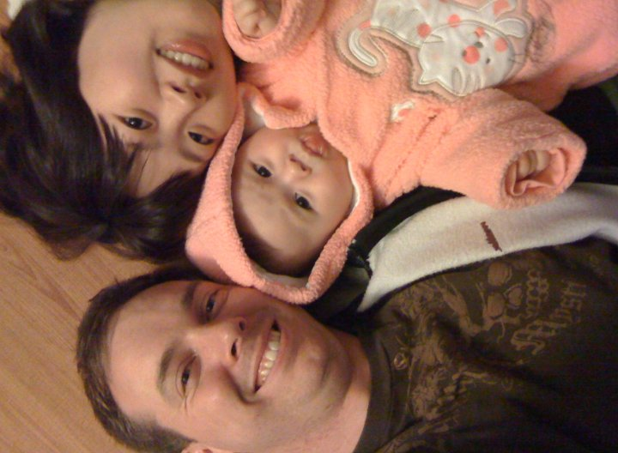

The role of family as central to the health and well-being of children is recognized and supported through a respectful family-provider partnership based on equality. Families are celebrated for their strengths, expertise, cultures, and tradition; their knowledge, skills and experience are utilized collaboratively in the decision making process.

Family Centered/Centric

Studies have found that family-centered practices (i.e., those that treat families with dignity and respect, and build upon family strengths[8]) produce positive outcomes related to overall family functioning compared to practices that were not family-centered (see Appendix C, Principles of Family Support).

In a meta-analysis of family-centered practices involving the synthesis of 52 studies and including over 12,000 participants, it was found that family-centered practices improved self-efficacy beliefs (i.e., belief in one's capabilities to achieve a goal or an outcome[9]) of parents, improved parent perception of competence, confidence, and parental enjoyment, improved family functioning, and improved parental judgments about their children’s behavior[10]. Furthermore, families who made the greatest strides in skill development fared much better independently after services were terminated[11].

Family-centered practices fall into two primary categories: 1) Relational, and 2) Participatory.

Relational practices include beliefs and behaviors generally associated with good clinical practice such as[12],[13]:

* Positive beliefs about the family and an ability to identify their strengths,
* Active listening,
* Empathy and compassion,
* Honesty and trustworthiness,
* Respect,
* Belief in the family’s competence, and
* Celebrating accomplishments and attributing the accomplishments to the family’s actions.

Participatory practices built upon strength-based provider-family partnerships[14], [15]:

* Provide individualized, flexible and supportive services that are responsive to the family’s identified needs and priorities,
* Build skills and capacities of family members,
* Involve the family in the decision making process, identifying goals, developing and implementing plans, and achieving desired outcomes,
* Incorporate all family members when appropriate, and
* Include family participation in program design, implementation and evaluation.

**Highlights of Promising Practice: La Familia Sana**

*La Familia Sana demonstrates family-centered practices by making families central to the decision making process, and by involving families in program design, implementation and evaluation*

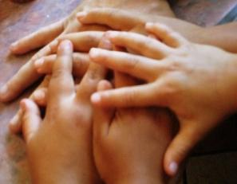Monterey County Children’s Behavioral Health Department’s La Familia Sana/The Healthy Family employs a Systems of Care (SOC) philosophy to offer a coordinated network of community-based support to meet the needs of children and youth with mental health issues, and their families. SOC “is an approach to services that recognizes the importance of family, school, and community, and seeks to promote the full potential of every child and youth[16].  Among the SOC core values is that services are “family-driven”, that is, families have a primary decision making role in the care of their own children, and in program planning. La Familia Sana *ensures the principal role of families by placing them in the center of the decision making process*.

La Familia Sana employs multiple family centered/centric practices including:

*Seeking family input on program materials* - Families are asked to review outreach materials to ensure that the materials are clear and are not stigmatizing.

***V****oice in the Care of Their Child* – Family members work together in equal partnership with professionals *to make decisions about the care and services for their child*. The family participates in discussions and is educated on the services available. Together with the team of professionals the family makes a decision about the best course of action, supports/services they wish to receive, and are supported by the SOC team to implement the plan.

***Hiring Staff with Lived Experience* -** La Familia Sana hires staff who have been through or have a family member who is receiving mental health services. Staff with lived experience provide invaluable input and expertise to program service and delivery. They are able to better understand the perspective of parents and caregivers who are receiving services for their child’s emotional well-being. Youth Mentors connect with and engage youth in an authentic manner that promotes youth involvement.

***Family Advisory Committee* –** La Familia Sana strives to have an authentic, meaningful partnership with a mutually defined vision with the **Family Advisory Committee (FAC). The FAC provides *feedback to the program on what’s working well and what needs to be improved*. Individuals on the FAC are motivated to ensure that families have the knowledge and resources to access services.**

***Youth Council* – A Youth Council was established to engage youth as active *contributors to the design and evaluation of programs and services*. Youth need to be organized around a purpose. The Youth Council also raises funds to support youth based activities and help homeless youth with supplies.**

**List of Resources**

**Family Centered/Centric**

On-line

**Towards Developing Standards and Measurements for Family-Centered Practice.** Beach Center on Disability, Kansas University. Review of the literature on the development of the concept of family-centered service delivery. Website: <http://www.beachcenter.org/Research%5CFullArticles%5CPDF%5CP1_TOWARD%20DEVELOPING%20STANDARDS.pdf>

**Parent Involvement: Making it Happen**, (Summer 2001). Article on involving parents in program design, implementation and evaluation. Working Strategies, 5(3), 1-11. Website: <http://www.familyresourcecenters.net/assets/library/23_summer01.pdf>

**Parent Involvement: What Parents Teach Us**, (Fall 2001). Article on the benefits of involving families. Working Strategies, 5(4), 1-11. Website: <http://www.familyresourcecenters.net/assets/library/24_fall01.pdf>

**Customer service plan and organizational assessment.** First 5 Santa Cruz County developed a customer service plan to provide exceptional customer service to families. In addition, they developed an organizational self-assessment tool on customer service. Website: http://www.first5scc.org/service-integration-project#customerservice

**Elements of Best Practices in Family Centered Services, (June 2000).** School of Social Work, University of Illinois at Urbana-Campaign. By S. J. Wells, Website: <http://www.cfrc.illinois.edu/pubs/Pdf.files/fcsbest.pdf>

**Family-centered Casework Practice –** This site includes various resources for family-

centered casework practice which encompass the range of activities designed to help families with children strengthen family functioning. Although the focus is on family-centered casework practice for children and families involved in the Child Welfare System, many of the resources are applicable to a variety of services. Website: http://www.childwelfare.gov/famcentered/casework/index.cfm

Written

**Research synthesis and meta-analysis of studies of family-centered practices, (2008).** This research report summarizes the results of a meta-analysis of 52 studies involving over 12,000 participants from seven different countries. The findings show that family-centered practices are correlated with positive outcomes for the parent, child, and family. By Dunst, C. J., Trivette, C. M., & Hamby, D. W. Asheville, NC: Winterberry Press

**Characteristics and Consequences of Family-centered Helpgiving Practices,** (**2005, June).** A bibliography of resources that serve as a foundation for understanding family-centered practices that build parent and family capacity and strengthen parent and family functioning. Center for the Advanced Study of Excellence in Early Childhood and Family Support Practices, By Dunst, C. J., & Trivette, C. M. CASEmakers publication, 1(6), 1-3.

**Capacity-building family-centered help giving practices, (2007)**. Article summarizes research and identifies the major components of family-centered practices. By Trivette, C.M., and Dunst, C. J. Winterberry Research Reports, 1(1), 1-10.

**Community-Based**

*Alisal Family Resource Center Mural*

*A house full of people is filled with different points of view.*

*~ New Zealand Proverb*

Community-Based

In the community, of the community, for the community; centered in and around a particular community, and reflective of community needs and dynamics.

Census and organizational data indicate that communities and neighborhoods are rapidly growing more diverse. Each community has its own culture and unique needs and realities. Effective service providers are those that respect the values, self-determination, and priorities of families, and translate their needs and desires into appropriate resources, supports, and services (Magrab, 1999)[17].

Service providers endeavor to provide services that are reflective of community needs and dynamics. They achieve this through ongoing assessment and input from families and the community thus ensuring that services are relevant to the community and are based in the community.

*Providing community-based services requires that organizations[18]:*

* Establish relationships with key community members who know the community well
* Are embedded in the community and are contributors to the community-building process[19]



*There is no power for change greater than a community discovering what it cares about.  
 ~* [*Margaret J. Wheatley*](http://www.betterworldheroes.com/wheatley.htm)



* Emphasize the importance of creating strong connections to the neighborhoods and community through the development of vital and relevant family support programs[20]
* Engage members from diverse communities in a community assessment process
* Forge partnerships with organizations that represent diverse cultures and the broader early childhood services community (health, mental health, education, etc.)
* Encourage the use of supervision as a time for reflective learning

*Community-based organizations gather information on the following:*

* What level of diversity exists within the community?
* What knowledge exists about the community and what do we need to know?
* What are some ways to gather background information and what resources are available?
* How can a community assessment process and interviewing techniques be used to gather information?
* How can reflection on and integration of this information be reinforced and contribute competent services for young children and their families?

**Highlights of Promising Practice: Dads in Action**

*Dads in Action demonstrates promising practices related to offering services in the heart of communities in Monterey County.*

Dads in Action, a program designed to support the parenting roles of fathers, uses a mobile community based service delivery strategy to bring services into the heart of communities throughout Monterey County. Dads in Action partners with agencies to *offer workshops at established community service hubs*, such as the Family Resource Centers, schools, and other community-based organizations.

In addition to offerings services at these locations Dads in Action *offers workshops at apartment complexes, churches, and at worksites during lunchtimes or at other employer hosted events* (e.g., employee picnics). Locations in the community are selected based on familiarity to the participants, and ease of access.

**Highlights of Promising Practice: Family Resource Centers**

*Family Resource Centers, by design, are centrally located in a community.*

Family Resource Centers (FRCs) are community-based by design. They are commonly housed on or near school campuses, embedded in neighborhoods, associated with apartment complexes, or a converted house[21]. FRCs *are located within walking distance of a large number of families* or are located near a transit hub. FRCs *build community by forming critical partnerships with other service providers* (e.g., local clinics, foodbanks, WICs) and expanding available services to families and children through co-located programs and services at the FRC. Alisal, King City, Castro Plaza, Monterey Peninsula School District, and Pajaro Family Resources Centers are examples of FRCs located on school campuses or in the heart of their communities.

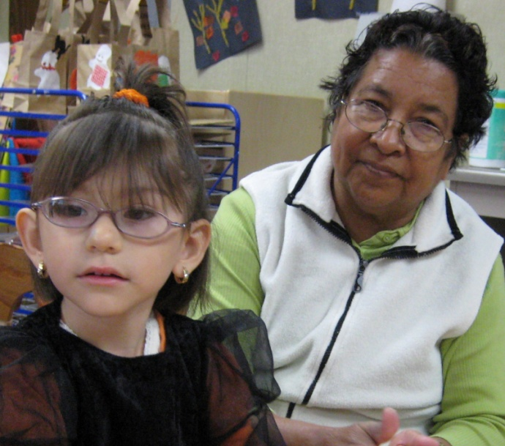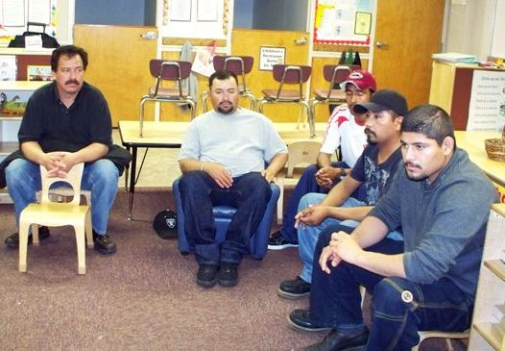

**Coordinated**

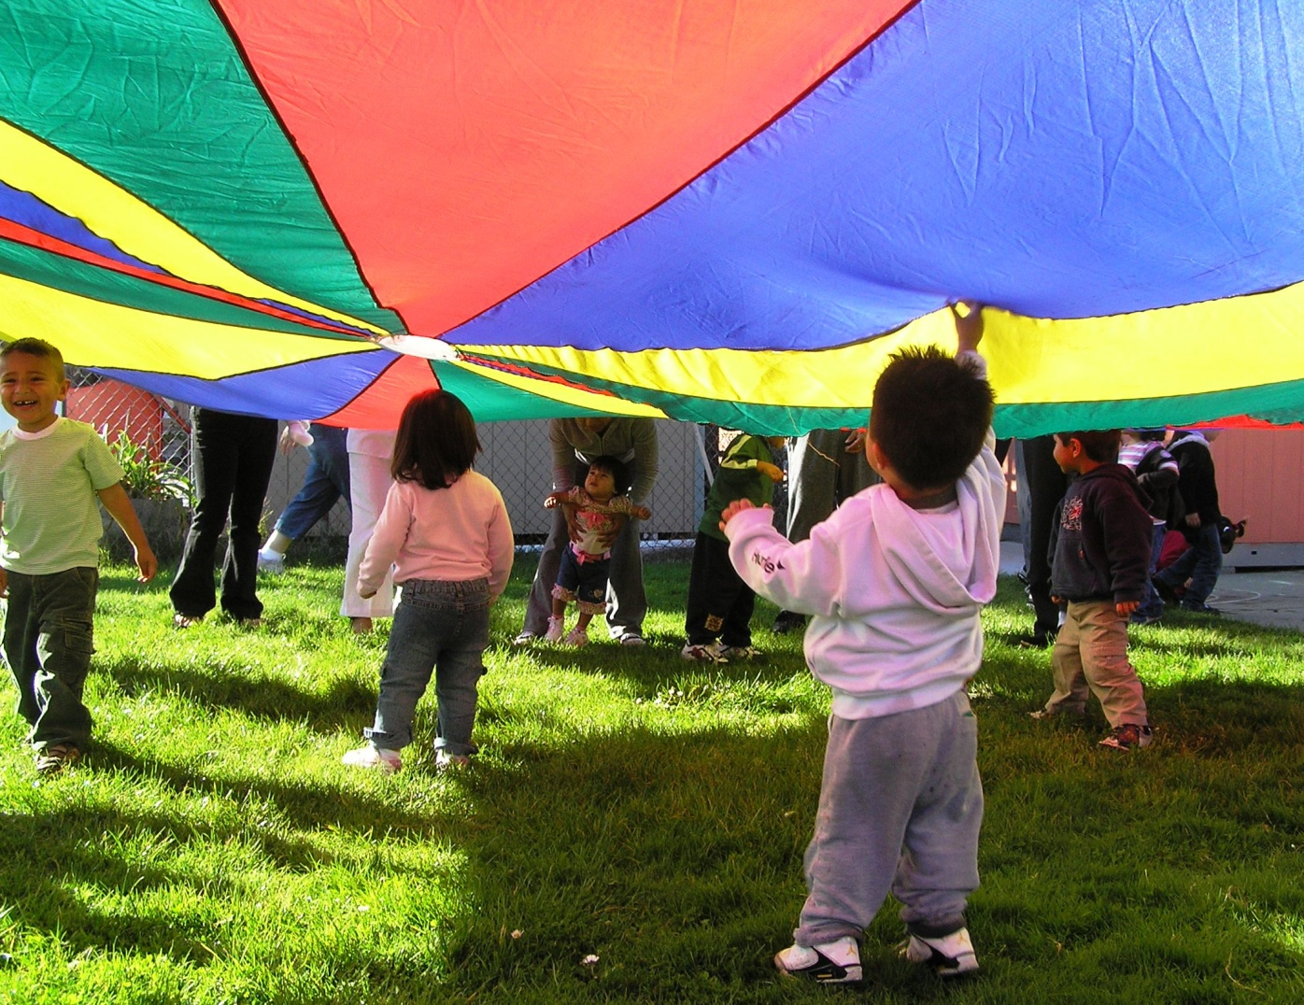

En la unión está la fuerza.

By working together we are stronger.   
~ Mexican Proverb

Coordinated

Working together harmoniously in a collective effort to support families and children, maximize resources, reduce duplication, and produce positive outcomes for the community.

An essential component for meeting the needs of a community is to ensure that public services are known, well coordinated, and fully utilized. This requires that different agencies, across multiple sectors (e.g. schools and health care), work together and involve community members to identify redundancies. Families receiving services are often the most familiar with the variety of programs available in a community and can be a valuable resource.

As state and federal resources diminish, community-based organizations continually seek opportunities to coordinate, collaborate, and when possible, integrate their programs so that families can access services with ease. Some strategies to develop and/or strengthen coordinated efforts are[22], [23]:

* Develop an understanding of the objectives, operations and services of other programs



*Many things we need can wait, the child cannot… To them we cannot say tomorrow, their name is today.*

*~ Gabriella Marella*



* Increase communication, resource sharing and joint planning among local agencies
* Develop a common vision and alignment on goals and objectives
* Align practices
* Co-sponsor community events and classes
* Assess services to reduce duplication and maximize resources
* Work in multi-disciplinary teams
* Organize cross-training of staff when possible
* Document and evaluate coordination efforts
* Coordinate internal processes and communication

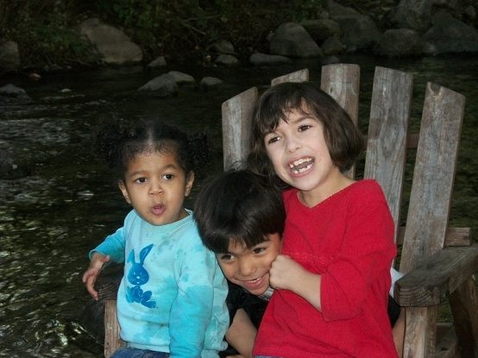

**Highlights of Promising Practice: MCSTART**

*MCSTART, as a promising practice, demonstrates the power of collaboration.*

The Monterey County Screening Team for Assessment, Referral, and Treatment (MCSTART) is an *inter-agency collaborative* providing a comprehensive system of community resources to identify, assess, refer and treat children who have been prenatally exposed to alcohol and other drugs. MCSTART was *developed collaboratively* and the program structure was *integrated by design*. Components of services from three agencies [i.e., Door to Hope – Lead Agency, Family and Children’s Services (Department of Social and Employment Services), and Monterey County Children’s Behavioral Health (Health Department)] *collaborate on the MCSTART program*. The MCSTART partnership is formalized through the development of an autonomous program and organizational structure and the existence of a *shared vision, contracts, written guidelines, clearly defined roles and responsibilities, joint decision making, and shared accountability*. In addition, MCSTART *services are co-located*.

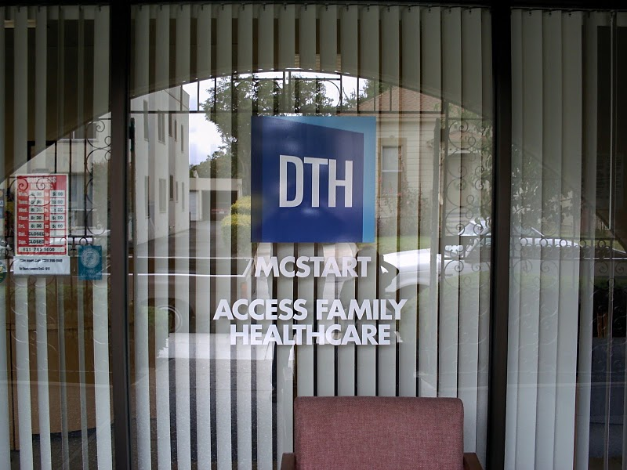

Therefore, a family can access services through one location and by completing one set of forms to receive services from all the MCSTART partners.

Comprehensive case management services are foundational to the effectiveness of the MCSTART program due to the nature of the target population (i.e., children who have been prenatally exposed to alcohol and other drugs, trauma, and a host of other challenges that compromise healthy development). MCSTART has established extensive connections and processes for cross-referrals with community service providers throughout Monterey County. The case managers work tirelessly to *coordinate services* and share information and resources with community partners so that risk factors can be mitigated. The additional coordination augments core MCSTART services and effectively shores up the safety net for children and families and supports their journey to independence.

Educating service providers on best practices for working with children who have been put at risk served a strategic goal to build community capacity to respond appropriately in a *coordinated fashion* to the needs of this population. MCSTART sponsored numerous trainings for providers and parents and brought nationally recognized experts in the field of child abuse, attachment, and prenatal exposure to alcohol and other drugs. Through the process of education, service providers not only increased their knowledge and skills but developed vital relationships with one another and MCSTART which laid the foundation for a *comprehensive coordinating system*.

*Three agencies - one program – one location - one website – one brochure – one set of forms – one set of charts – one set of licenses – one set of financial audited statements.*

Community Resources

MCSTART

**List of Resources**

**Coordinated**

On-Line

**What is service integration and how can it be established? (2009).** Written information on service integration. Promising Practices Network, Website: <www.promisingpractices.net/sd2a.asp>.

**Factors to promote coordination.** (2009). Urban Institute Research of Record. Website: <http://www.urban.org/publications/408026.html>.

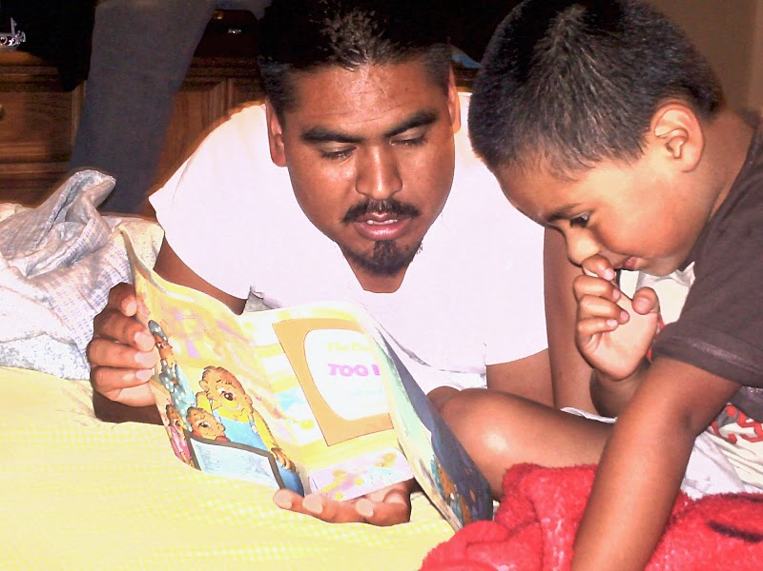



A truly rich man is one whose children run into his arms when his hands are empty.

~Author Unknown



**Flexible Hours**







Flexible Hours

Flexible staffing and program planning to ensure services are provided at convenient times so that family members can participate year round without conflicts with school, work or other commitments; includes evenings, weekends and holidays.

Once a leading fishing and whaling port, Monterey County's economic mainstays now are tourism, the military and agriculture. Because of the nature of these industry sectors, work schedules are often staggered throughout the day and during the year. Many families work during traditional Monday through Friday, 8:00 a.m. – 5:00 p.m., schedules. Other families work on weekends and evenings.

Families are often confronted with additional hardship when the very services they need to improve their circumstances are only offered during traditional hours. Many working parents do not have the luxury of taking time off to access needed services. They may have to lose paid working time (which further depletes already limited financial resources), hamper advancement opportunities, suffer harassment and/or resistance from employers, be prohibited from taking time off for other than leave covered by law (e.g., Family Leave Medical Act), or in some cases risk losing their job. The consequences of not having accessible services during non-traditional hours is substantial.

Organizations supporting working parents strive to create flexible service hours to enable families to better manage their demanding lives. Even with limited resources organizations are able to structure hours of operation to meet the current needs and realities of families without further jeopardizing the very families who need the services most. For instance, an organization could choose to close during one of more days of the workweek and open on weekends and/or evenings. Conducting a local assessment of needs helps organizations design flexible hours of operation.

Families throughout Monterey County have consistently reported, through community input processes conducted by ***F5MC*** , a strong need for services to be offered in the evenings and on weekends.

Flexibility of hours reflects the ability, and willingness, of organizations to be continually responsive to emerging family and community challenges:[24]

* Program offers flexible schedules to accommodate working parents
* Program’s hours of operation are accessible to families

**Highlights of Promising Practice:**

**Intermediate School 218, New York City (Community School)**

*The community school demonstrates the power of partnership to offer flexible hours during non-traditional times and days throughout the week, and to provide services year round.*

A creative partnership – Community School District 6 – was formed between the New York City Board of Education and the Children's Aide Society to serve youth who have been put at risk in a variety of ways[25]. The community school, in addition to providing education to children, offers a variety of educational, cultural and social enrichment programs for children and their families. The *school is open twelve months out of the year*, *even though the year-round schooling doesn’t exist* in New York City. The regular academic year occurs from September to June. The *school is open six, sometimes seven days a week, from 7:00 in the morning until about 9:00 or 10:00 p.m*. *It is open on Saturdays and sometimes even on Sundays, and it's open all summer long.*

The collaboration provides students and parents with services that include extended day programs, medical assistance, dental assistance, and mental health services. Through the partnership a "one-stop shop” of education, community supportive services for children and families, and assistance is provided. Students attend school during the day, sometimes for extended periods to participate in enriched classes, sports, music, and the arts. The library is open during after-school hours to make sure that kids have access to constructive, positive learning activities six or seven days a week up to fifteen hours a day.

Parents and other community members access services, including courses ranging from aerobics to English as a second language, from 6 p.m. to 10 p.m. during the school week. As a community school, parents are recruited to volunteer in the school as aides and in other services provided by the partnership. For example, parents have been trained to give vision and hearing tests at the medical clinic. There is also a family resource room and classes, recreational programs, and workshops on parenting, citizenship, and so forth.

Where services are not available in the school, referrals are made to other agencies.

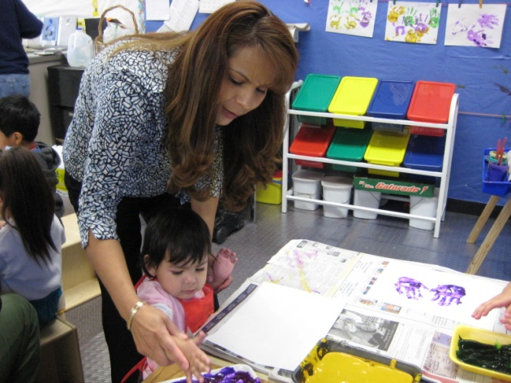

**Appendix A**

**Standards of Conduct**

**National Standards on Culturally and Linguistically Appropriate Services, (CLAS).** U.S. Department of Health and Human Services, The Office of Minority Health. The CLAS standards are primarily directed at health care organizations[26].

**Standard 1**  
Health care organizations should ensure that patients/consumers receive from all staff member's effective, understandable, and respectful care that is provided in a manner compatible with their cultural health beliefs and practices and preferred language.

**Standard 2**  
Health care organizations should implement strategies to recruit, retain, and promote at all levels of the organization a diverse staff and leadership that are representative of the demographic characteristics of the service area.

**Standard 3**  
Health care organizations should ensure that staff at all levels and across all disciplines receive ongoing education and training in culturally and linguistically appropriate service delivery.

**Standard 4**  
Health care organizations must offer and provide language assistance services, including bilingual staff and interpreter services, at no cost to each patient/consumer with limited English proficiency at all points of contact, in a timely manner during all hours of operation.

**Standard 5**  
Health care organizations must provide to patients/consumers in their preferred language both verbal offers and written notices informing them of their right to receive language assistance services.

**Standard 6**  
Health care organizations must assure the competence of language assistance provided to limited English proficient patients/consumers by interpreters and bilingual staff. Family and friends should not be used to provide interpretation services (except on request by the patient/consumer).

**Standard 7**   
Health care organizations must make available easily understood patient-related materials and post signage in the languages of the commonly encountered groups and/or groups represented in the service area.

**Standard 8**  
Health care organizations should develop, implement, and promote a written strategic plan that outlines clear goals, policies, operational plans, and management accountability/oversight mechanisms to provide culturally and linguistically appropriate services.

**Standard 9**  
Health care organizations should conduct initial and ongoing organizational self-assessments of CLAS-related activities and are encouraged to integrate cultural and linguistic competence-related measures into their internal audits, performance improvement programs, patient satisfaction assessments, and outcomes-based evaluations.

**Standard 10**  
Health care organizations should ensure that data on the individual patient's/consumer's race, ethnicity, and spoken and written language are collected in health records, integrated into the organization's management information systems, and periodically updated.

**Standard 11**  
Health care organizations should maintain a current demographic, cultural, and epidemiological profile of the community as well as a needs assessment to accurately plan for and implement services that respond to the cultural and linguistic characteristics of the service area.

**Standard 12**  
Health care organizations should develop participatory, collaborative partnerships with communities and utilize a variety of formal and informal mechanisms to facilitate community and patient/consumer involvement in designing and implementing CLAS-related activities.

**Standard 13**  
Health care organizations should ensure that conflict and grievance resolution processes are culturally and linguistically sensitive and capable of identifying, preventing, and resolving cross-cultural conflicts or complaints by patients/consumers.

**Standard 14**  
Health care organizations are encouraged to regularly make available to the public information about their progress and successful innovations in implementing the CLAS standards and to provide public notice in their communities about the availability of this information.

Appendix B

**A Few Facts about Indigenous Populations in Monterey County**

**Indigenous Communities\*** - Of the more than 60 different indigenous communities that remain alive in Mexico, the following are the ones with the largest representation in California: Mixtecs (from the state of Oaxaca and Guerrero), Zapotecs, Triquis, Chatinos, Chinantecos and Mixes (from the state of Oaxaca) and P’uhrépechas (from Michoacan). Each of these indigenous communities have their own language and culture that differentiate them from one another*.

**\*\*Population** – Some researchers estimate that indigenous immigrants will represent over 20% of California’s farm labor by 2010.

In 2000, the U.S. Census identified 2,420 indigenous persons in Monterey County but it is estimated that the population is now between 7,500 to 10,000.

**Principal Languages** **Spoken by Indigenous Communities**  - Triqui, Mixtec, Zapateco, and Otomi.

**Principal Indigenous Communities** **in Monterey County** – Greenfield, Salinas, Seaside, Marina, King City, Castroville, Prunedale, Aromas, Los Lomas, and Soledad and Pajaro.

*Taken from the Centro Binacional para el Desarrollo Indígena Oaxaqueño website: < www.centrobinacional.org

** Kresge, L. (2007). Indigenous Oaxacan communities in California: An overview. California Institute on Rural Studies, <http://www.cirsinc.org/documents/pub1107.1.pdf>

**Recommendations for Working with Indigenous Communities[27]**

* Approach indigenous communities through existing social structures and leadership networks, with respect for existing norms. The indigenous communities have strong social networks and organizing skills. Drawing upon these networks by developing relationships of trust with leaders of these organizations is by far the most effective way of improving the effectiveness of outreach to the communities and by extension, increasing their access to health and social services.
* Work with existing organizations who serve indigenous communities, such as CBDIO and Radio Bilingue. These organizations are able to provide detailed insight into the specific social networks, strengths, and challenges of indigenous communities, as well as provide ideas regarding effective outreach strategies, contacts for interpreters, connections with other outreach organizations and information regarding the cultural nuances of working with indigenous populations.
* Hire and use *promotores(as)* for direct outreach to indigenous communities, word of mouth campaigns, and direct enrollment of community members in health and social service programs.
* Utilize culturally appropriate outreach methods, including radio, audio/visual media and pamphlets using pictures and images.
* Promote increased opportunities to train indigenous language speakers as interpreters.
* Consistently engage indigenous communities through community meetings, cultural festivals, sports events, and health fairs.
* Increase outreach and services to indigenous communities through mobile services and outreach programs.

Appendix C

#### Principles of Family Support Practice*

1. Staff and families work together in relationships based on equality and respect.
2. Staff enhances families' capacity to support the growth and development of all family members - adults, youth, and children.
3. Families are resources to their own members, to other families, to programs, and to communities.
4. Programs affirm and strengthen families' cultural, racial, and linguistic identities and enhance their ability to function in a multicultural society.
5. Programs are embedded in their communities and contribute to the community-building process.
6. Programs advocate with families for services and systems that are fair, responsive, and accountable to the families served.
7. Practitioners work with families to mobilize formal and informal resources to support family development.
8. Programs are flexible and continually responsive to emerging family and community issues.
9. Principles of family support are modeled in all program activities, including planning, governance, and administration.

*Principles of Family Support Practice were originated by Family Support America

Bibliography and Endnotes

1. Trivette, C. M. & Dunst, C. J. (2007). *Capacity-building family centered helpgiving practices*. Winterberry Research Reports, 1(1), 1-10.
2. *National Standards on Culturally and Linguistically Appropriate Services*, (CLAS). U.S. Department of Health and Human Services, The Office of Minority Health. Retrieved from: <http://raceandhealth.hhs.gov/templates/browse.aspx?lvl=2&lvlID=15>
3. Goode, T. and Jones, W. (2007). *A Guide for Advancing Family-Centered and Culturally and Linguistically Competent Care.* Georgetown University Center for Child and Human Development. Pages 3-4.
4. Tervalon, M. & Murray-Garcia, J. (1998). *Cultural humility versus cultural competence: A critical distinction in defining physician training outcomes in multi-cultural education*. Journal of Health Care for the Poor and Underserved, 9(2), 117-125.
5. Hunt, L. M. (December, 2001). *Beyond cultural competence: Applying humility to clinical settings*. Park Ridge Center Bulletin, 24.
6. Kresge, L. (2007). *Indigenous Oaxacan communities in California: An overview*. California Institute on Rural Studies, Retrieved from <http://www.cirsinc.org/documents/pub1107.1.pdf>
7. Centro Binacional para el Desarrollo Indígena Oaxaqueño, Retrieved from <http://centrobinacional.org/>
8. Dunst, C.J., Trivette, C.M., & Hamby, D.W. (2008). *Research synthesis and meta-analyses of studies of family-centered practices*. Winterberry Press: Asheville, North Carolina.
9. Pajares (2002). *Overview of social cognitive theory and of self-efficacy*. Retrieved March 28 2010 from http://www.emory.edu/EDUCATION/mfp/eff.html
10. Dunst, Trivette, & Hamby, (2008).
11. Wells, S.J. (2000, June). *Elements of best practices in family centered services*. School of Social Work, University of Illinois at Urbana-Champaign, Retrieved from http://www.cfrc.illinois.edu/pubs/Pdf.files/fcbest.pdf
12. Wells, (2000, June).
13. Trivette & Dunst,. (2007).
14. Wells, (2000, June).
15. Trivette & Dunst,. (2007).
16. SAMSHA Systems of Care retrieved from<http://systemsofcare.samhsa.gov/>
17. Hepburn, K. (2008). *Culturally and linguistically competent services to support young children, their families, and school readiness.* Georgetown University Center for Child and Human Development.
18. Hepburn, (2008).
19. Wells, (2000, June).
20. Wells, (2000, June).
21. *Family Resource Centers: Vehicles for change*, (2000). The California family resource center learning circle. Retrieved from http://www.familyresourcecenters.net/assets/library/9_vehicles3.pdf
22. Promising practices network, (2009). *What is service integration and how can it be established?* Retrieved from <www.promisingpractices.net/sd2a.asp>
23. Urban Institute Research of Record, (2009). *Factors to promote coordination.* Retrieved from [www.urban.org/publications/408026.html](http://www.urban.org/publications/408026.html)
24. San Francisco Family Support Network (2009). San Francisco Family Support Standards. Retrieved from http://www.dcyf.org/Content.aspx?id=1436&ekmensel=14_submenu_18_link_2.
25. Retrieved from <http://www.ncrel.org/sdrs/areas/issues/educatrs/leadrshp/le3newyk.htm>
26. *National Standards on Culturally and Linguistically Appropriate Services*, (CLAS). U.S. Department of Health and Human Services, The Office of Minority Health. Retrieved from: <http://raceandhealth.hhs.gov/templates/browse.aspx?lvl=2&lvlID=15>
27. Kresge, L. (2007). *Indigenous Oaxacan communities in California: An overview*. California Institute on Rural Studies, Retrieved from <http://www.cirsinc.org/documents/pub1107.1.pdf>